St Thomas Community Builder -
COVID-19 Update

I have been overwhelmed by the community spirit that St Thomas has shown in supporting one another in the current COVID-19 crisis. A big thank you to all the many people who are busy organising Whatsapp or phone calls with their neighbours or local people they know. Just to let you know that community leaders, the services (Exeter City council, Devon Co Council) as well as charitable organisations are getting together to co-ordinate a community response to this crisis and to the community. They are keeping me updated.
I have put together this brief update to share with you what we have learnt about the support available in St Thomas during this crisis. This information was correct at the point of writing but I am sure we all recognise that we are in an unprecedented time of change and things move quickly.
Contents:
- Local Services
- Opportunities to Connect
- Final Note
- Contact Details
- ideas for staying at home
Local Services:
St Thomas Health Centre (GP Surgery)
All routine appointments have been cancelled at St Thomas Health Centre. Hours and contact are restricted to ensure the virus does not spread. Patients with should ring the surgery first 01392 676676 before coming in and importantly follow government guidelines as stated here - https://www.gov.uk/government/collections/coronavirus-covid-19-list-of-guidance if they are displaying the COVID19 symptoms. When patients ring the surgery, all cases/ appointments are being triaged by the team of GPs.
Luxton’ s Pharmacy
The Pharmacy remains open, but with reduced hours which are subject to change/staffing levels – 9.30-1, 2-5 Monday to Saturday. If picking something up, please check their website or ring before 01392 274880. The pharmacy is allowing 1 in, 1 out, observing the 2 metre distance advice. Staff are operating behind a Perspex screen. As usual, don’t go out if you/your family have any COVID 19 symptoms.
Boots on Cowick Street
Tel 01392 251777. Hours are also subject to change/staffing levels and they only allow 2 people in at a time. All staff are working extremely hard to fulfil prescription services.
Cowick Street Post Office (please note there are also post offices open on Okehampton road and Broadway stores, Broadway)
Currently the Post Office is still open and all services are available except passport applications. The hours run may be subject to change, so do check. Contact them on 01392 254353.
The four St Thomas churches are working together generally to ensure the wellbeing of the residents of St Thomas, by looking after those who need it most among their volunteers.
St Thomas Parish Church
The church is now closed for public worship. There are online services via links on the website or Exeter.anglican.org.resources/coronavirus-guidance/Sunday-services-to-watch-online/
St Thomas Methodist Church
The Church is now closed and you can access the live act of worship each week www.methodist.org.uk.
St Thomas Baptist Church
The Church is now closed and you can access their You Tube channel with worship live or recorded: https://m.youtube.com/channel/UCBsLydyrWCvnvk7aN_Zur6A
And you can join them for a 30 minute talk on the Bible on Sunday morning:
https://bit.ly/39fzeLM
St Thomas Riverside Church
The church is closed and you can access an interactive worship service via their website – loveexeter.com on Sundays at 10.30 am.

Stagecoach Bus
Stagecoach are running a restricted timetable primarily to ensure hospital staff and key workers can get to the hospitals and workplaces.
Shillingford Organics
Vegetable box delivery to the St Thomas and Alphington area. They are no longer accepting new customers but existing customers with accounts can make an order. Delivery on Thursdays.
Friends of St Thomas Surgery
The group have temporarily had to suspend their face to face visits. There are volunteers on hand to help the most vulnerable patients with telephone befriending, support with medicine delivery and shopping where needed. Contact Friends of St Thomas by calling 01392 676676 option 4 and leave a message for Denise.
Exeter Library Service
This is closed to the public but will post books out & in some cases deliver them. Contact them for further information.

Exeter City Council
Exeter City Council and Wellbeing Exeter are committed to working together to provide practical help and support to groups, organisations and individuals.
To sign up to e-bulletins:
ExeterCityCouncil@public.govdelivery.com
Exeter City Council are setting up a dedicated phone hotline 01392 265000 to assist people during this time of need which aims to ‘gather information from people and organisations who want to offer their help and support to the community response.’ Jo Yellend, director of Exeter City Council 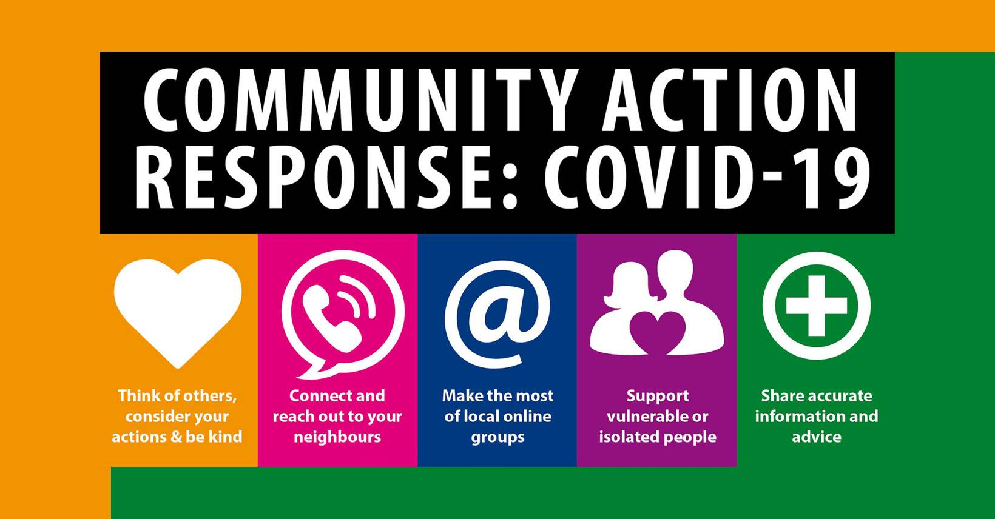
The Facebook Group to find updates about COVID19 - Exeter Coronavirus Updates - https://www.facebook.com/groups/exeterupdates

Age Uk
Age UK based on Cowick street have a phone number if you are/someone you know locally is older and may need some support 01392 202092. They will offer over the phone support and where practicable help delivering things to doorsteps.

Food/Shopping/ Takeaways
During the COVID 19 crisis many things in life have changed, so I’ve tried to find some local businesses who are operating still, for us all to support. This list is, of course, subject to change but so far businesses that are open for takeaways or shopping are:
Mc Colls newsagents – St Thomas Precinct & Dunsford Hill
Coop at St Thomas Precinct
Coop on Isleworth road
Tescos on Cowick street
Papa Johns – contactless delivery – pay over the phone and they deliver to you, ringing you upon arrival at your house. No cash and no collection
Mr Choys takeway, Cowick street - delivery service, cards only
M&S on Exebridges are open
Premier Store Princess Street, off Alphington rd
Broadway stores – Broadway (they do phone delivery too – 01392 272052)
Burrow Butchers on Cowick street
Souvlaki & Gyros on Buddle Lane – are open at lunch 11 am- 13:00 Mon, Wed-Sun (not Tuesday) for delivery and collections 17:00 - 22:00
Crusty Cob Bakery St Thomas Precinct – open but do call before if you need to check 01392 362002
Lucky Phoenix takeaway on Cowick street is open for deliveries
Goa Spice Premier, Cowick street is open for deliveries
Veg in a box - https://veg-inabox.com/ - deliveries of fruit and veg, meat, eggs, cheese, bread, meat, eggs, cheese tel 01392 873036
Good news from Shaun the manager at Coop at St Thomas Precinct:
’Can I please take this opportunity to say THANK YOU ST THOMAS COMMUNITY from all the team at Co-Op Cowick St! This very difficult time we find ourselves in, the community spirit shown has been awesome. Supporting us from the decreased operating hours, the partial closure on Saturday to allow us to fill the fresh and today's customer count restrictions. I've witnessed customers allowing the older and vulnerable in first whilst patiently waiting outside to be allowed in. I'm not from St Thomas, but I would be immensely proud if I was a resident. Thank you and please, stay safe.’
Opportunities to Connect
Rainbow Trail
Lots of residents shared the idea of getting people to draw or paint a rainbow and put it in their window for children to spot when they are out for a walk. What a lovely way to come together. Let’s see how many pictures we can spot by the end of the week. Fraser and Wheeler Estate Agents are publishing them too on their Facebook page, just for fun.
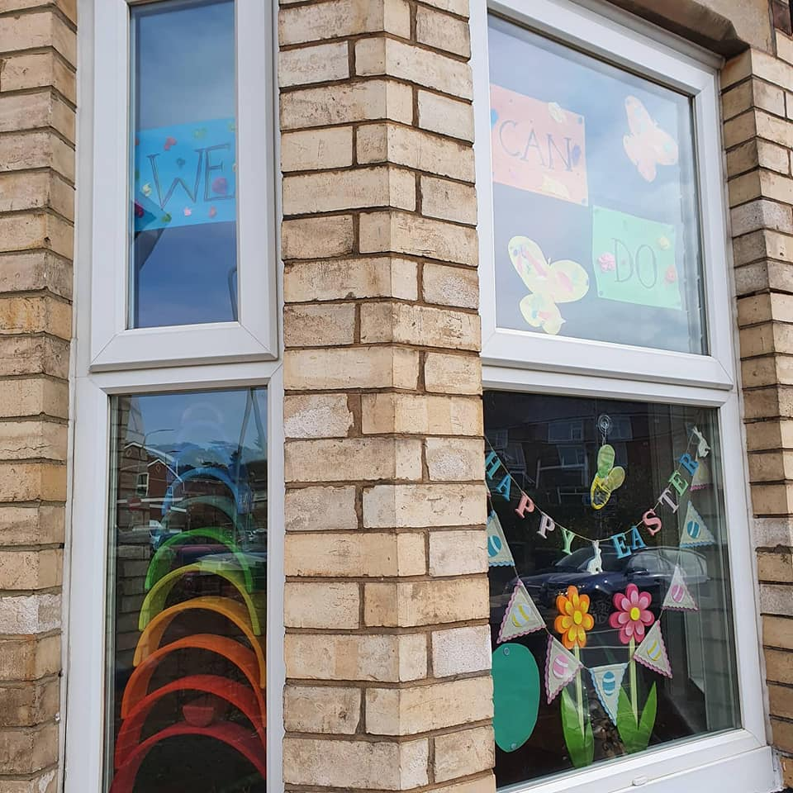
Whatsapp
Many residents have swapped numbers or set up groups via Whatsapp. So people stay connected on a street by street basis. This enables people to really support each other – a phone conversation for someone who lives alone can make a huge difference. Other people kindly shop, pick up prescriptions, dog walk or do DIY for their neighbours. What about people who don’t have the internet or a smart phone? Age UK, the GP surgery at St Thomas as well as the churches are looking out for their most vulnerable people. Exeter City Council, in conjunction with many other agencies are (as already mentioned) running a phone line to support residents as well as match offers of help to people in need. This information will be sent out to every address in the city – both support and needs/concerns for people during this COVID 19 crisis.
Have you set up a WhatsApp group to connect with your neighbours? Let me know. If you would like to do this and need support setting one up, then please do contact me. If you wish to find out if there already is one – feel free to ask – I can ask my contacts.
Next Door
Next Door is a neighbourhood hub for connecting with your community and to exchange useful information, goods and services. Why not join your neighbourhood now at www.nextdoor.co.uk
Final Note
It saddens me to say but there are people who are using this crisis as a means to scam people. I have been aware of a couple of scams that are currently operating. Residents have been asked to donate to ‘the Red Cross’ falsely. Please be careful during this time and look out for one another.
Contact Details:
During the COVID-19 crisis I will be mostly home based and providing support to people locally by telephone and online. Please contact me via Facebook, messenger, email or telephone. Contact details below:
Chloe Pooley, St Thomas Community Builder
Email: stthomascb@gmail.com
Telephone: 07935 218747
Facebook: CB St Thomas
Twitter: @chloe_stthomas
Ideas for staying at home:
-Joe Wicks PE sessions You Tube
-online free course – too numerous to mention. Many colleges and universities are offering courses
-download audio book from Devon Libraries –see their digital library for downloading/streaming eBooks, EAudioBooks and eMagazines –www.devonlibraries.org.uk/web/arena/join-thelibrary
-home library service for older /vulnerable customers 0345 155 1001
-learn a language – 6 months free on ‘Babel’
-Facebook group – Family lockdown tips and ideas
----------------------------------------------------------------------------------------------------------------------------------If you have ideas please let me know and I can share it

